ASP.NET2003 – ASP.NET 2005 – ASP.NET 2008
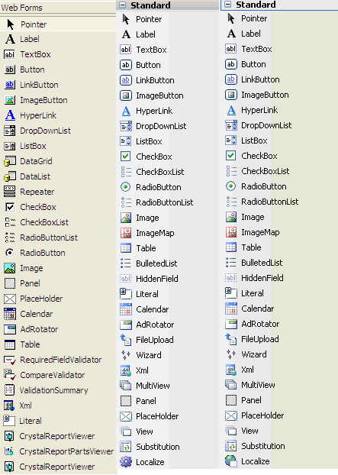

ASP.NET2003 – ASP.NET 2005 – ASP.NET 2008

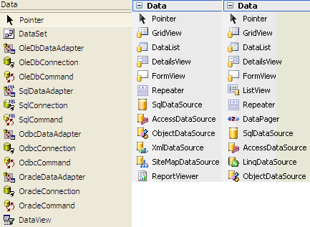

ASP.NET 2003
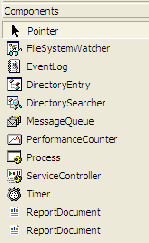

ASP.NET 2005 – ASP.NET 2008

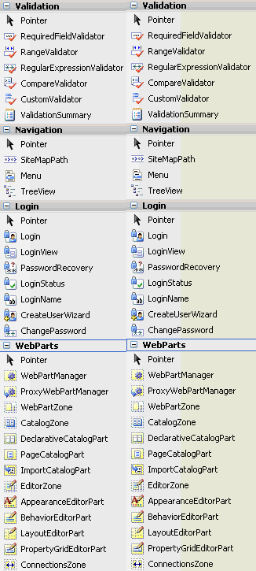

ASP.NET2003 – ASP.NET 2005 – ASP.NET 2008

